COLLEGE OF ARTS&SCIENCES—additional info for new instructors 8/20/18
Jen Smith (jensmith@wustl.edu)

Some numbers:

- ~4400 ArtSci undergrads, ~7000 total
- Freshman class (2018) 1222/1803
- Credits to graduate: 120
- Typical credits in major: 30-40
- Target semester load: 15 credits
- Lecture class: 3 credits; Lab class 4-5 credits
- Maximum semester load w/out special permission: 21 credits
- Minimum load for full time student: 12 credits
- Classes start: 10 minutes past scheduled time
- ~~50% of students enter interested in Biology and/or pre-health
- ~28% apply to med school
- 74% complete more than one major (+ minor, + second major)
- Largest majors: Anthropology, Psychology, Biology
- ~1/3 go straight to grad school, ~1/3 go to work force, return to school w/in 7 years, ~1/3 stay in work force
- Grad rate (4 yr): 89%, (6 yr): 95%

Grades
What they mean (e.g., what’s an A?) It’s up to you! No guidelines from us. We just ask that the method of grading is transparent to the student.

Grades other than letter grades: You may choose whether it is possible for students to take your course CR/NCR (pass/fail) or as an audit. [You can’t change retroactively—if the option was available at the time a student registered, you can’t take it back!] YOU CHOOSE what constitutes a pass, or a successful audit. Please communicate this on your syllabus.
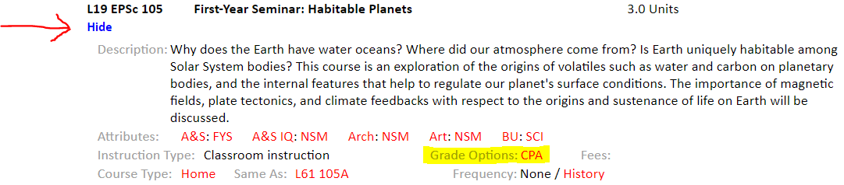

Midterm grades: if possible, please submit for: all first year students, anyone heading towards a C- or lower. *Helpful to let students know what this midterm grade represents. You will get a reminder.

Incomplete: If a student experiences medical or personal problems that make satisfactory completion of course work difficult or unlikely, s/he may request a grade of Incomplete (I) from one or more instructors. In such a situation, the student should take the following steps:
- Meet with the instructor before the final examination or due date for the final paper to discuss the request.
- If the instructor consents, agree on the work remaining to complete the course and on a date when it will be submitted.
If these steps are not followed, the instructor is under no obligation to award a grade of I. Failure to submit completed work by the last day of classes of the next full semester will result in the I grade being changed automatically to a grade of F. For spring semester courses, this will be the last day of summer classes, typically mid-August.
You can change a student’s grades via egrades for several weeks after grades are due; you can change grades through a paper form (ask your department/program admin) until the student’s degree is granted.
Retake: Students whose performance in a course has not met their expectations are permitted to retake the course, receive a second grade, and have the symbol R, denoting the retake, placed next to the grade for the first enrollment. The course should be retaken for the same grade option as that for which the course was originally taken. All registrations will show on the transcript; however, only the grade and units of the final enrollment will be used to calculate the GPA.

Students enrolling/leaving classes: Students register for classes in the previous semester (mid-November for spring semester classes, mid-April for fall; incoming first years register by mid-July). There is a tradition of shopping; students typically enroll in more than they will take (or as backup for a waitlist). The add/drop deadline is the Thursday of the second week of class (Sep 6, 9 pm). After the add/drop deadline, they may only add the course *with your permission*, and if they wish to leave the class, they must withdraw, which will appear on their transcript (with a W, doesn’t impact GPA). They may withdraw until the end of the 12th week (November 16, 9 pm). After that, only medical reasons will allow a student to withdraw (direct student to: Assistant Dean Sean McWilliams, smcwilliams@wustl.edu).
Students wanting exceptions to these deadlines can file an exceptions petition : http://forms.artsci.wustl.edu/policies/exception-petition
In order to provide consistency for all students, the drop and withdraw deadlines are not at a faculty member’s discretion. Only the College can grant an exception to these. We do so only with significant extenuating circumstances (i.e., not, “I really thought the deadline was tomorrow.”).

Final exams: the date and time of the final exam was provided to the students at the time they registered for classes. Any cumulative final assessment should be given on that scheduled date, *not* during the last week of class, or during reading days. It is the *student’s* responsibility to know those dates and to plan their travel accordingly. You are *not* obliged to move your final exam to accommodate their travel. There is an unkillable urban legend that if a student has three exams on one day that a faculty member is obliged to move one. This is not true.

Academic Integrity: For an overview, https://artsci.wustl.edu/resources/policies-procedures#anchor-group-8809
Contact Assistant Dean Sean McWilliams, smcwilliams@wustl.edu with questions.
Cases are heard by a student/faculty panel. The faculty member will present their case, the College can support with evidence gathering if needed. The panel will decide whether or not a student is found in violation, but grade sanctioning is up to the professor. We’re a “three-strike” institution—first offense is typically failure of the assignment or course, second is suspension, third, expulsion. There is an appeal process that can be invoked which involves the University Judicial Board.

Proposing new courses: Course proposal forms can be found here:
https://artsci.wustl.edu/curriculum-proposal-forms Departments and programs have their own procedures which would need to be followed prior to submission to the ArtSci curriculum committee.

When you’ll hear from us/someone about a student in your classes:
If a student is having significant health problems, or a traumatic event and has engaged their advisor, their advisor may reach out to inform you and coordinate accommodations. If we learn a student is hospitalized, you will hear from the College (we don’t always hear). Student Health Services doesn’t provide standard “doctor’s notes”—students can get verification that they have been seen at Student Health, but that won’t contain “please excuse so-and-so because of problem y”.
Someone in the college will check in midterm (or sometimes earlier) asking about any students we are concerned about.
You may hear from someone (likely Kim Webb) associated with the Relationship and Sexual Violence Prevention Center. Please be as accommodating as you can be.

When you should contact us: Whenever you’re concerned about a student. You’re welcome to contact me directly, or the student’s advisor(s)—you can find the advisor info through WebFAC.
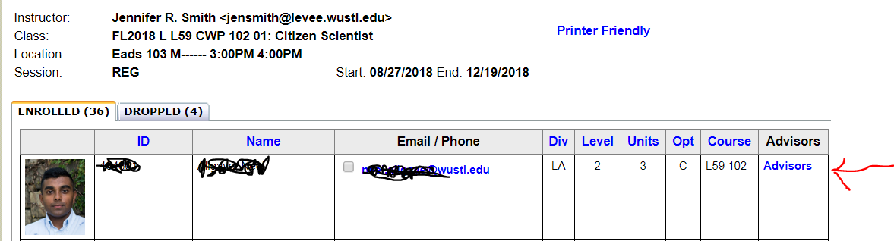
If you are concerned a student is a danger to self or others, call WUPD; 935-5555 (on campus) or 911 (off campus)
You can also report a significant concern about a student to WashU Cares, who will follow up. https://washucares.wustl.edu/

Students receiving disability accommodations Overview here: http://cornerstone.wustl.edu/disability-resources/request-and-use-accommodations/information-for-faculty/
You are not obliged to provide accommodations for anyone who hasn’t given you a VISA form from Cornerstone. It is worth reading any forms you get as soon as you get them, and if anything on the VISA is ambiguous (“flexible attendance” has caused us problems in the past) you should have a conversation with the student and/or Heather Stout about how any accommodations will work.

Course evaluations We are trying to build a culture where students are more likely to complete semester-end course evaluations—current response rates average only 50%. Please encourage students to complete in any way you are comfortable. The most effective practices we’ve seen: offering students 10 minutes during class in the last week to pull out smart phones, devices, etc., and complete the evals, professors discussing the changes they have made in their courses as a result of past evaluation responses, and building course eval participation into a student’s participation grade, or as extra credit (even a miniscule amount that has effectively no chance of changing a final grade seems to boost participation rates significantly).
To see what students can see—go to https://sites.wustl.edu/courseevalresults/
[You can see this plus individual comment text].

Costs associated with your courses Inasmuch as the world of academic publishing allows, please keep required expenses (texts, etc.) for your course low. Your subject librarian may be able to help you find open source or other cheap texts. Providing information as early as possible to students (through completing bookstore orders) will help them shop around. If your course has additional costs which are not term-billed (lab fees are term-billed), please give students as much advance notice as possible. Talk to your department and/or the college (me) about covering additional costs (e.g., performance tickets) for students.

Campus resources of interest (in no particular order):

The Bulletin: all things student academic policy related
http://bulletin.wustl.edu/

Arts&Sciences Undergraduate Degree Requirements
http://artsci.wustl.edu/resources/undergraduate-degree-requirements

Student mental health support:
https://shs.wustl.edu/Pages/letstalk.aspx

Diversity/Identity
https://diversityinclusion.wustl.edu/
https://diversity.wustl.edu/framework/advisory-best-practice-groups/lgbt-advisory-committee/

Content Statement Statement: (also see below)
https://diversity.wustl.edu/framework/advisory-best-practice-groups/rigor-respect-learning-environment/

Inclusive learning environment: (also see below)
https://diversity.wustl.edu/framework/advisory-best-practice-groups/inclusive-learning-environment/

Teaching Center: https://teachingcenter.wustl.edu/
Syllabus template with all the boiler plate!:
https://teachingcenter.wustl.edu/resources/course-design/syllabus-template/

Title IX:
https://rsvpcenter.wustl.edu/resources/title-ix/

Emergency preparedness:
http://police.wustl.edu/emergencypreparedness/Pages/default.aspx
https://emergency.wustl.edu/be-prepared/

FERPA:
The Family Educational Rights and Privacy Act guarantees the privacy of student educational records, which include all coursework that has received evaluative comments or grades by an instructor. Instructors must ensure, in the process of posting grades or returning graded material, that the students’ grades or evaluations are not visible to or determinable by anyone without a right of access to the information. Only the individual student, and those university employees with a legitimate educational interest in the course or student outcome may have access to student educational records.
_________________________________________
Appropriate methods of returning graded work/posting grades include:
-Faculty or teaching assistants personally handing work to students known to them.
-Faculty/teaching assistants/administrative assistants returning work personally to students upon display of identification
-Campus mail (material placed in sealed envelope)
-Using the Blackboard gradebook
-By email *to the student’s WashU email address*.

If faculty randomly assign students a unique identifier, and assignments/exams only contain that information- not a student’s name or ID- materials can be left in non-secure locations for students to pick up.
If grades are posted publicly, physically or on a website, students’ names or student IDs may *not* be used as an identifier, and students should *not* be listed in alphabetical order.
Faculty may ask students to sign a waiver, allowing their work to be returned in whatever manner specified, and acknowledging that in those circumstances other students might be able to observe their grade/evaluation. If students opt out of signing the waiver, material must be returned to them in a secure manner.
A student’s advisor would be considered to have a legitimate educational interest in the student.

Social Media Guidelines:
When using social media as a part of a class, faculty must seriously consider questions of student access and privacy, as well as the maintenance of professional and equitable relationships with all members of the class. Not all students in a class may have accounts with the particular social media platform the faculty member wishes to use; faculty should be sensitive to student concerns regarding the privacy of their personal data on some social networking sites. A student cannot be required to register with a non-university platform which collects personal data in order to participate in class activities or receive course information. Faculty are encouraged to use university-sponsored patforms for online discussion and interaction (e.g., Blackboard) wherever possible. Selective "friending" or "following" etc. of students who are currently enrolled in a faculty member's course outside of a dedicated course resource accessible to all students (even if initiated by the student) can produce the appearance of favoritism, and as such should be avoided.

Balancing Rigor and Respect in the Learning Environment

Statement of Principle: Introduction and Background
“Trigger Warning” describes an advisory preamble to subject matter that could potentially be disturbing to readers, listeners or students with a history of trauma, including sexual abuse and assault as well as racial or gender discrimination. These warnings have recently gained more attention as they pertain to an array of subject matter taught on college campuses. We recognize that some content in our learning environments may directly or indirectly interact with students’ prior experiences and understanding. As an institution it is important that we articulate our commitment to the principle of academic freedom and its necessity for academic rigor as well as to the cultivation of a supportive and inclusive environment for all who learn, teach and work at Washington University. We believe these values can be mutually compatible. The “Balancing Rigor and Respect in the Learning Environment” statement addresses these values.

Balancing Rigor and Respect in the Learning Environment: A Washington University Content Statement
A central mission of Washington University is the creation of knowledge through teaching and research. Learning takes place when we grapple with new and at times challenging ideas, concepts and perspectives, and this process not infrequently involves exposure to distressing facts and events. As an institution, we affirm the importance of academic freedom and the rigor it provides to our learning environments. At the same time, we remain mindful of the varied responses that subject matter can evoke in learners, especially those who have experienced trauma. We believe that upholding the values of academic freedom and maintaining respect for individual responses to course material are both important goals.
Students will have a variety of reactions to a course’s subject matter. In cases of general discomfort with course material, students are encouraged to see their respective instructor, academic adviser or program director to discuss course content or any related concerns. Faculty and staff can find resources for handling such situations through the Teaching Center. For specific instances in which course material seems likely to cause the re-experiencing of trauma, students should contact Student Health Services, Disability Resources, the RSVP Center or the Office of the Title IX Coordinator for assistance and/or to request reasonable accommodations for trauma-related disabilities or conditions. Faculty, staff and students can find additional resources for addressing such situations here. While instructors are not required to make fundamental alterations to their curriculum or course material, they are encouraged to be alert to possible adverse reactions to material, to consider reasonable accommodations, and to refer students to the above resources for additional support.

Best Practices for an Inclusive Learning Environment
The best learning environment — whether in the classroom, studio, laboratory or fieldwork site — is one in which all members feel respected while being productively challenged. At Washington University in St. Louis, we are dedicated to fostering an inclusive atmosphere, in which all participants can contribute, explore and challenge their own ideas as well as those of others. Every participant has an active responsibility to foster a climate of intellectual stimulation, openness and respect for diverse perspectives, questions, personal backgrounds, abilities and experiences, although instructors bear primary responsibility for its maintenance.
A range of resources is available to those who perceive a learning environment as lacking inclusivity, as defined in the preceding paragraph. If possible, we encourage students to speak directly with their instructor or TA about any suggestions or concerns they have regarding a particular instructional space or situation. Alternatively, students may bring concerns to another trusted adviser or administrator (such as an academic adviser, mentor, department chair or dean). All classroom participants — including faculty, staff and students — who observe a bias incident affecting a student may also file a report (whether personally or anonymously) utilizing the online Bias Report and Support System.

